

**CSI PROJECT REPORT ON**

**Report Generator**

**(Report Automation)**

**FOR**

**INFRA SUPPORT PLUTO COMMAND CENTER**

**OF**

**BMS PLUTO**

**Submitted by RAHUL KAMBLE**

* **PROBLEM STATEMENT:**

Currently at Command Center we perform Incident Management as well as Major Incident Management. In Incident Management our day-to-day responsibilities include 24x7 monitoring of alerts, ticket SLAs and reporting.

We send out more than 10 reports daily, most of which are repetitive in nature. The reports sent out require manual effort of copy pasting and formatting.

* This method is prone to manual errors.
* This method is time consuming due to the efforts taken.
* Great amount of text editing is done while working with e-mails and Excel sheets.
* **PROPOSED SOLUTION:**

Report generator is a work in progress GUI tool developed using Python scripting language. It aims to overcome the above mentioned problems.

Efforts Reduced: **For “Daily Hygiene Reports”**

* + - * + **Approx. time taken manually**: Minimum- 30 mins (3-4 reports)
        + **Approx. time taken by tool**: 50 seconds for 1 report

Resources Reduced:

* + - * + As an attended automation system the resource reduction hasn’t been estimated
        + MIM (Major Incident Management) is something that requires human effort and cannot be automated. This tool is aimed to enhance Incident Management process & make employees focus on MIM.
* Using this tool I aim to generate Command Center reports at the click of a button.
* Currently the **Daily Hygiene Reports** reports are working in full capacity while other internal reports in functioning capacity.

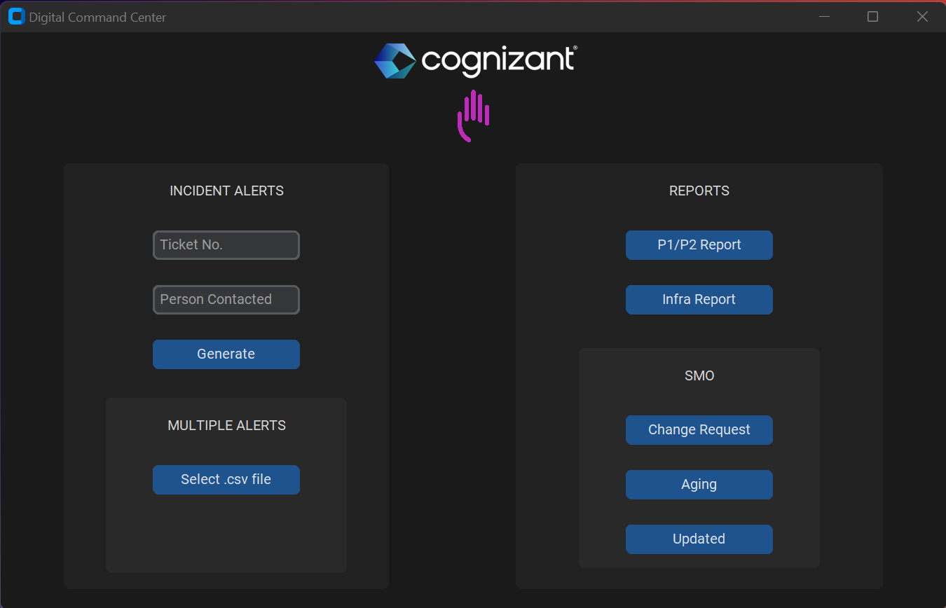

* This tool requires an input Excel/.csv file containing ticket details that can be obtained from Service Now portal and then selected through a file dialog.

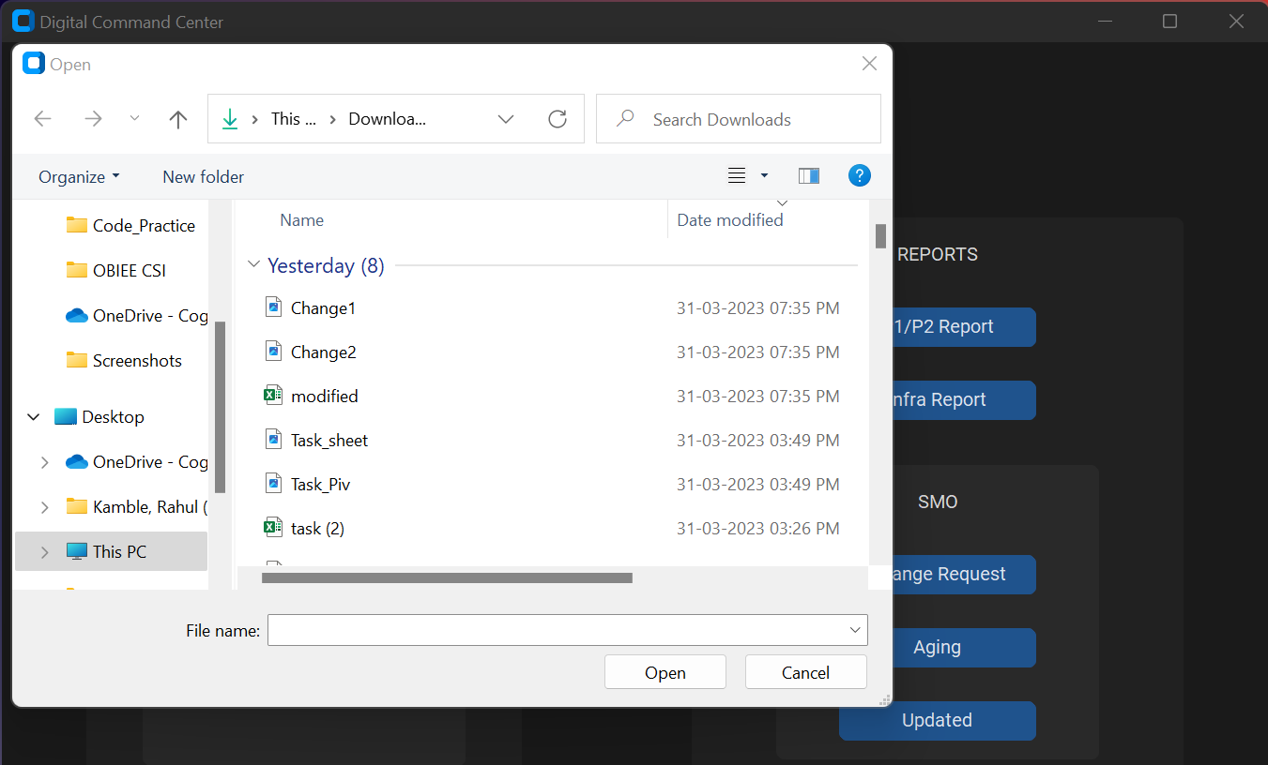

* After processing the file the tool extracts the necessary data, formats it and generates a ready email draft.
* The email draft contains the respective DLs mentioned in To and CC, Appropriate subject line. Time and date for reports both EST & IST calculated using the system time.

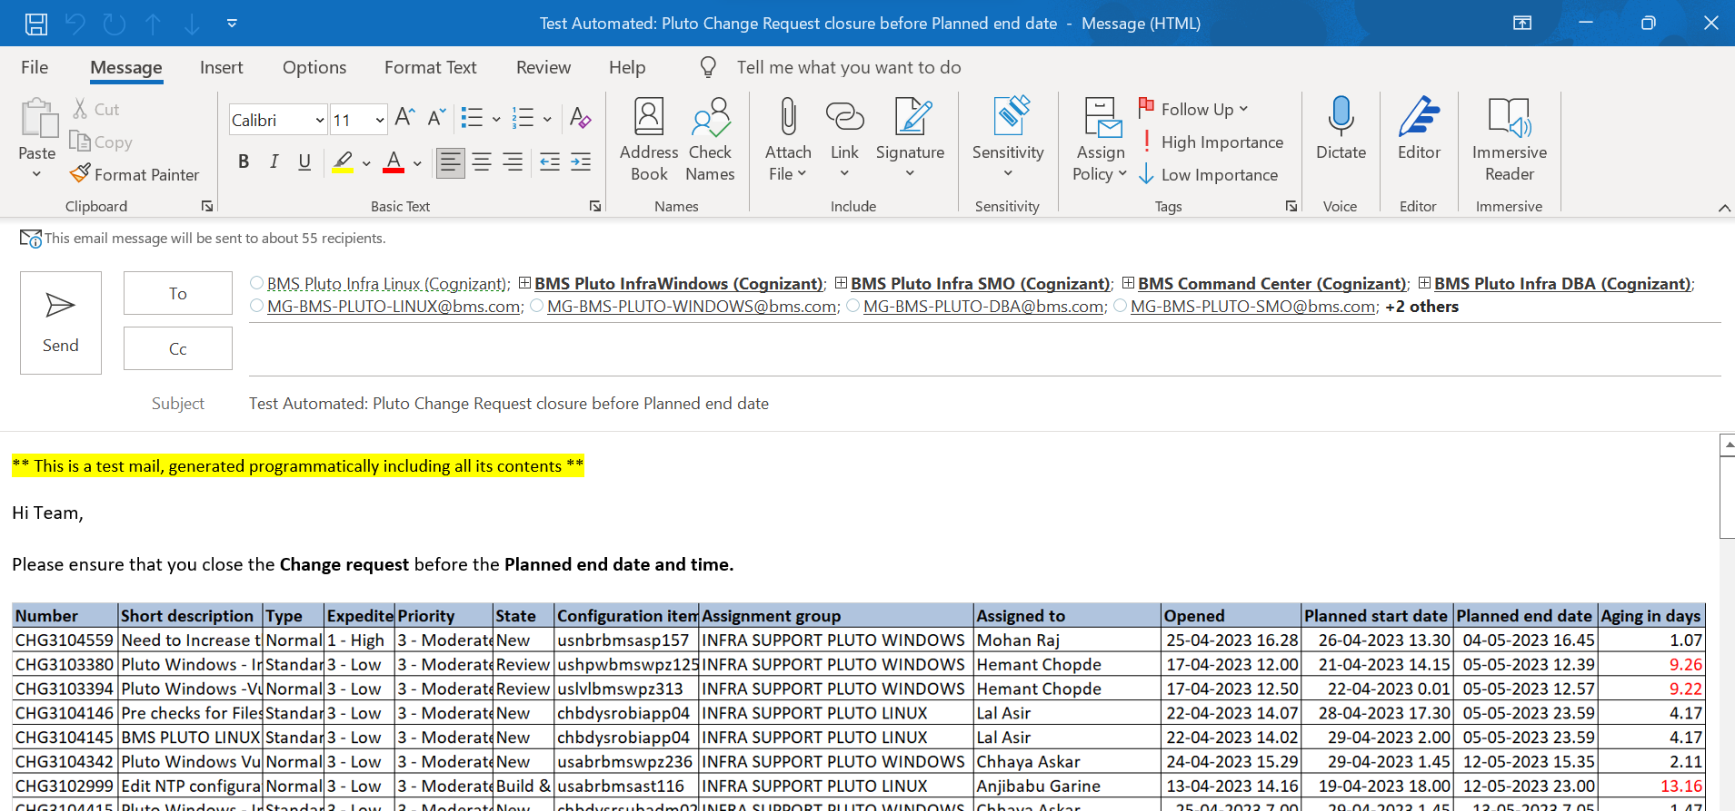

* For SMO reports it takes the excel file and performs all necessary operations like using formula, creating Pivot tables, filtering data etc. It then creates an email draft ready with all the necessary data.

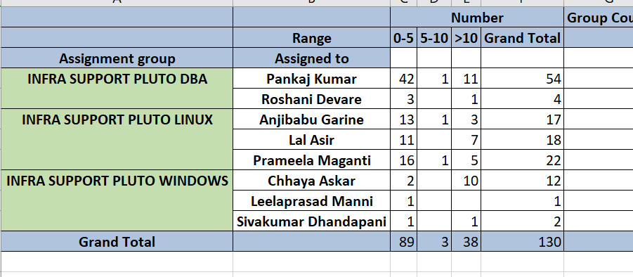

* For Infra(Ticket Status Report) and internal P1/P2 reports it mentions ticket details in appropriate cells

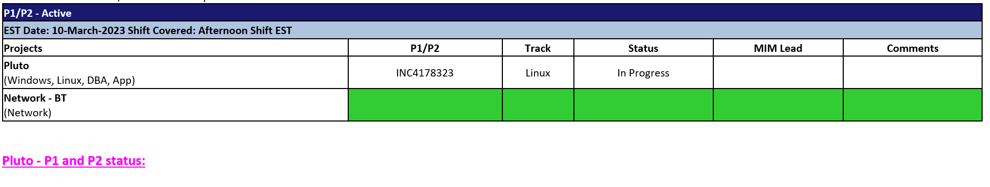

* Similarly for multiple alerts the tool checks the Assignment group in ticket details and selects the correct team DL.

* **SOFTWARE SELECTION & DEPLOYMENT:**
* **Language:** Python
* **Version:** 3.10.1
* This GUI tool is aimed to be deployed as an executable file on respective member’s systems so there won’t be the need to download Python on their machines.
* **SCOPE OF THE SOLUTION:**

**This tool is in progress, it now needs access to Service NOW to get the ticket details programmatically.**

* With this tool we’ll be able to digitalize Command Center operations.
* This will help associates focus more on the Major Incident Management part which requires human attention and communication skills.
* It will improve the speed and accuracy of the reports.
* This tool will particularly prove to be useful when there’s minimal staffing in the team.
* A GUI tool is easy to operate for everyone.